

Active directory basics

Praise Oduware



Contents

1.0 Lab Configuration 2

1.1 Workstation setup 2

1.2 Active directory services setup 4

1.3 Network setup 6

1.4 Connecting computer 10

2.0 User and group management 12

2.1 New users 12

2.2 New groups 13

2.3 Organizational unit 13

2.4 Adding users to groups 15

3.0 Group Policy 16

3.1 Creating and Linking GPOs 17

3.2 System setting changes via GPO 17

4.0 File permissions 19

4.1 Mapping network drive 19

4.2 Testing permission 22

5.0 Further practice 23

## 1.0 Lab Configuration

### 1.1 Workstation setup

Virtual box and the iso files for the workstations were downloaded and installed from the relevant sites. After installing virtual box, open and click new. Below are the steps for setting up the windows server

* Set name
* Set memory and processor as default
* Select “create a virtual hard disk”
* Look at overview summary and click finish
* On the virtual manager double click windows server
* Mount ISO and reboot
* Select language, time and currency format and input method and click next
* Ensure you select standard version with desktop experience when selecting operating system to install and click next
* Accept license terms and click next
* Select custom install and click next
* Select drive and click next to start the setup
* Once the setup is complete set an admin password and login into the device.

#### 1.1.1 Screenshots from server setup

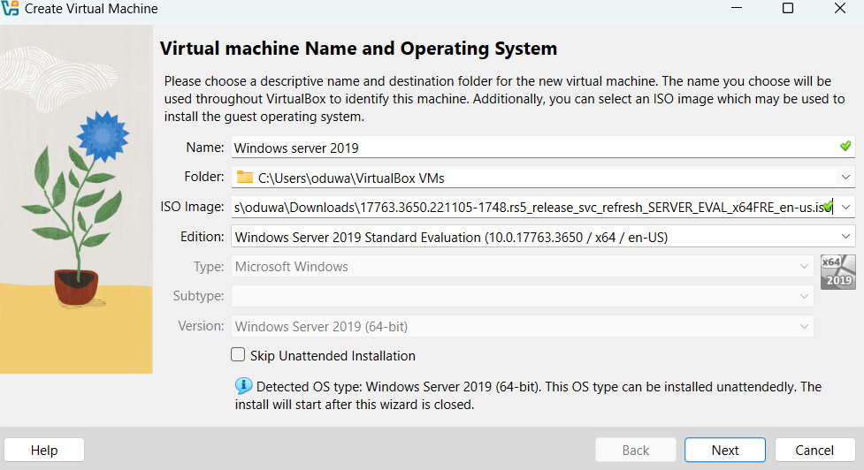

*1.1.1.1 ISO installation*

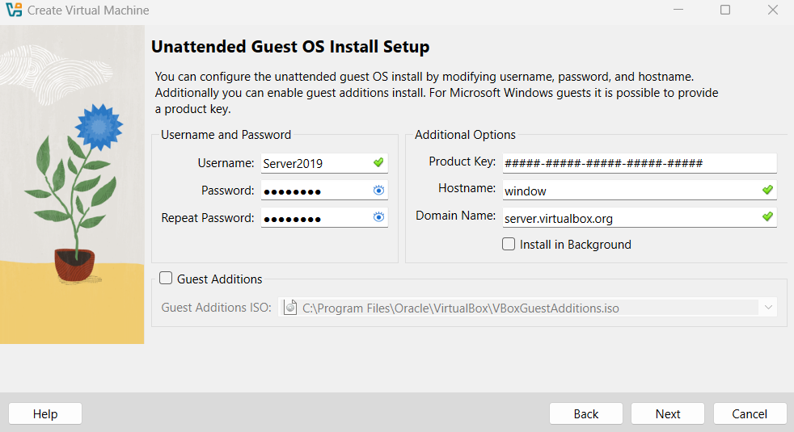

*1.1.1.2 Server username and password setup*

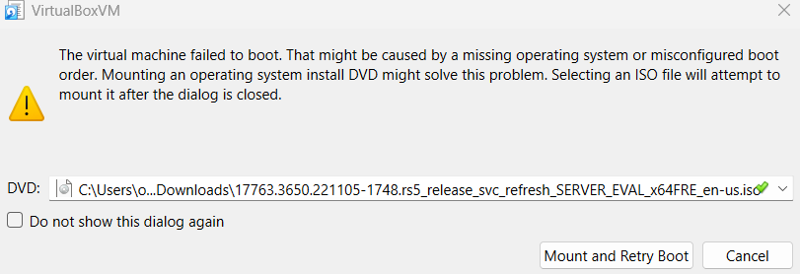

*1.1.1.3 VM mount*

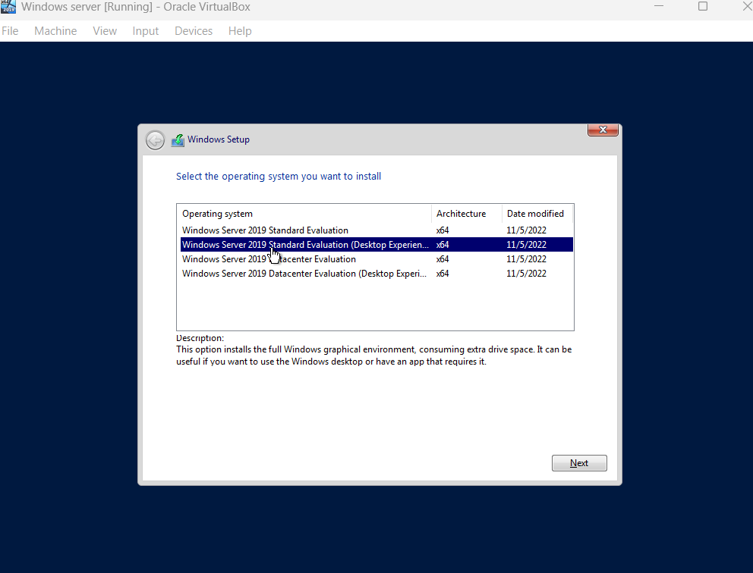

*1.1.1.4 OS selection*

N/B: If you want to resize Windows server VM or any other VM to fit the full screen, under the devices tab select Insert guest additions, run from the VM and reboot the VM. After logging back in under the view tab select full screen and the VM should take the entire screen.

### 1.2 Active directory services setup

Next is to set up the server to have the active directory service role and to do this simply open the add roles and features wizard, click next(default settings are fine) until you reach the server role section where you will check active directory domain services and click add features. Continue to click next and proceed to install the service.

Once the service is done installing close the window, click the flag icon on the top right of the server manager to show the recent tasks and click “promote this server to a domain controller". Below are the steps to follow when configuring the domain controller

* Under deployment configuration select “add a new forest” and type root domain name
* Under domain controller option set the password for directory service restore mode
* Under additional options wait until the NetBIOS domain name autofills, click next for the remaining steps and proceed to installation after prerequisite checks are complete

N/B: You will be prompted to sign out and log back in as a domain controller.

#### 1.2.1 Screenshot from active directory services

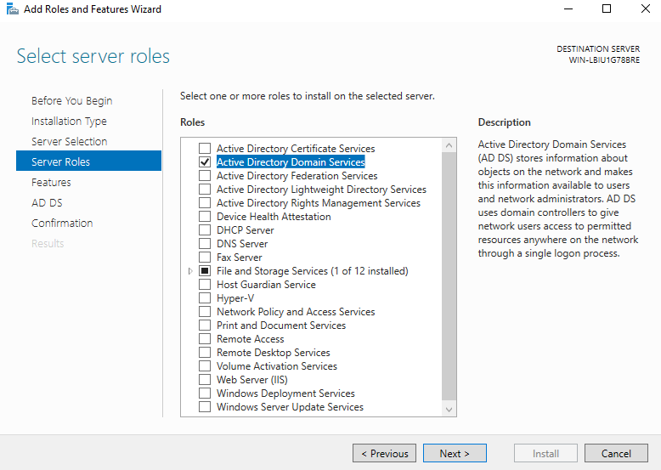

*1.2.1.1 Active directory Service addition*

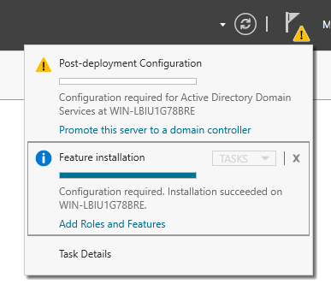

*1.2.1.2 Promote domain controller*

### 1.3 Network setup

To be able to start connecting computers to this forest you need to set up a user with administration privileges to add computers. Below are the steps to do so

* On the top right of the server manager dashboard navigate to tools and under it click “Active directory users and computers”
* Under the domain navigate to users, right click and select new then user
* Full the first and last name fields along with the user logon name then click next
* Set password, uncheck “user must change password at next login (since you will be using the system) and click next
* Verify the details and click finish

After creating the user you will need a computer to log on with these user credentials. Simply follow the steps used to setup the server except you will mount the ISO for the windows 10 operating system. While the windows 10 VM sets up you need to ensure both the user computer and the server are on the same network and below are the steps to do so

* In the oracle virtual box interface right click on the machines and go to settings
* Under network select attach to “bridged adapter”

Once the window VM is up in the bottom left click “Domain join instead” and set up accordingly. After logging into the windows VM remote access will need to be enabled and name changed. Below are the steps

* Open file explorer, right click “This PC” and select properties
* Under related setting select remote desktop
* Enable remote desktop
* Go back to related setting and click “rename this PC”
* Change name and restart

Once the User system restarts in order for the VM to connect to the domain server the DNS of the user VM will need to be changed to the IP address of the domain controller. Below are the steps.

* Open control panel
* Under computer settings navigate to network and internet and select change adapter setting
* Right click on ethernet and under its properties open the properties of ipv4
* Set the preferred DNS server to the IP address of the domain controller and the alternate to any known DNS server (8.8.8.8)
* To confirm connection open command prompt and ping the IP address of the domain controller

N/B: You will need to turn off firewall in the server and user VM settings to avoid any issues with connection in the network though in an actual IT environment the firewall would have been configured correctly. IPv6 should also be disabled and if you run into any issues restarting your host system and VM mostly solve network issues.

#### 1.3.1 Screenshots for network setup

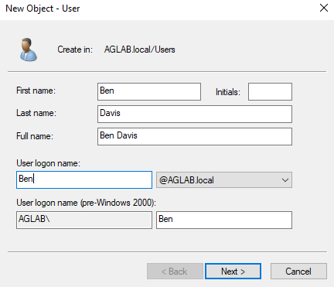

*1.3.1.1 New user*

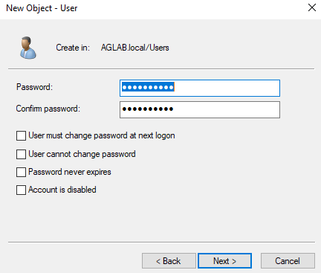

*1.3.1.2 User password*

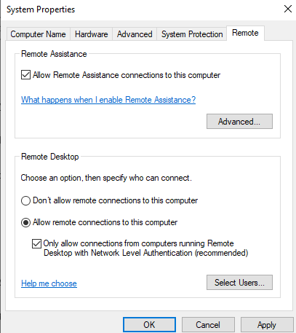

*1.3.1.3 Remote desktop enable*

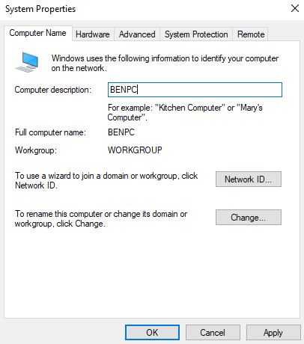

*1.3.1.4 PC rename*

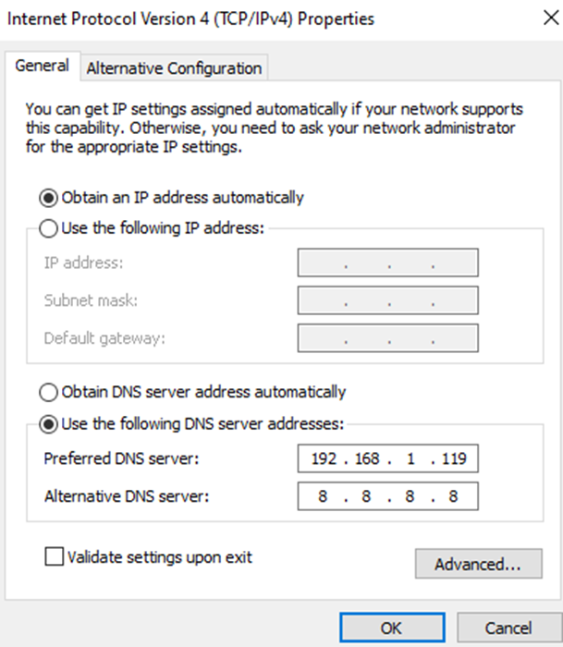

*1.3.1.5 Windows 10 IP configuration*

### 1.4 Connecting computer

To connect the computer to the domain below are the steps

* Open file explorer , right click this PC and select properties
* Select advanced system settings
* Under the computer name tab click change
* Select member of domain and type name of domain
* A window will pop up asking you to fill in the credential of an account that has access to the domain. Use the details of the user account previously created in the active directory.
* Once the windows system connects to the domain, you will be prompted to sign out and you can login using the user credentials.

#### 1.4.1 Screenshot from connecting computers

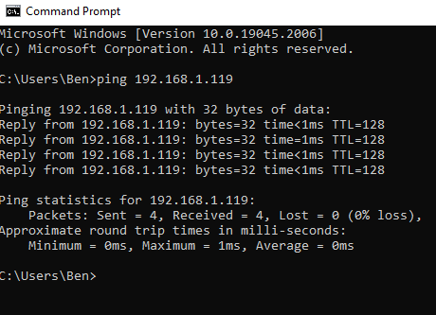

*1.4.1.1 Confirming PC can connect via pinging*

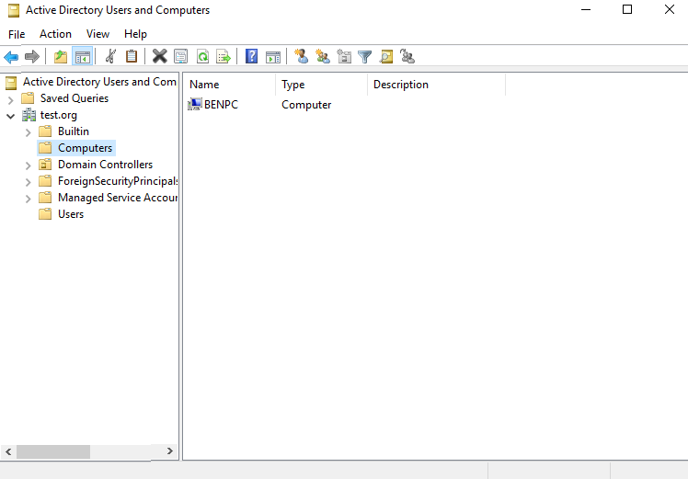

*1.4.1.2 Confirmation of PC in domain controller*

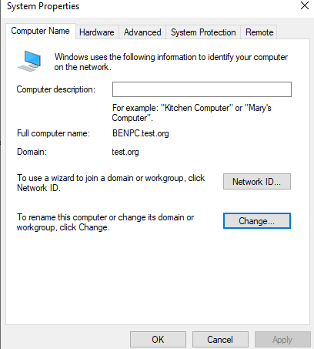

*1.4.1.3 Confirmation of PC in domain on windows 10 system properties*

## 2.0 User and group management

In 1.3 we created a user which we used to log into the domain on the windows 10 PC. In this section I will expand more on users and groups with the use of organizational units

### 2.1 New users

Following the steps shown in 1.3.1.1, two new users were created in the user container in addition to the previously created David account along with the built-in administrator and guest account in preparation for them to be transferred to organizational units

N/B: To make it easier to see all users use the filter option to single out the user object

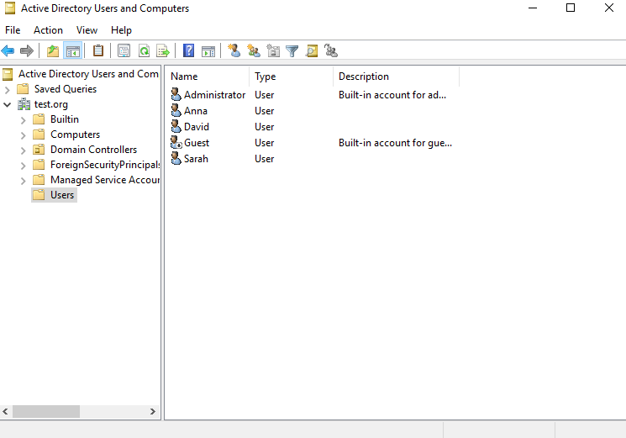

*2.1.1 Users*

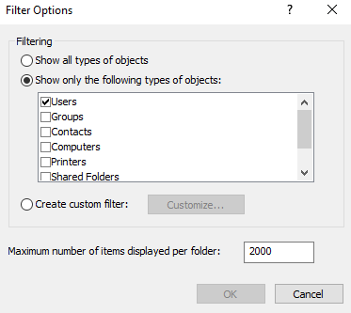

*2.1.2 Filter option*

### 2.2 New groups

Groups make it easier to apply policies and permission to multiple users that have been assigned to that group. Three groups were created in the user container in preparation to be transferred to organizational units. To create a group, right click on the user container, navigate to new and select group. You will be prompted to Name the group along with selecting the group scope and type. For this exercise the scope should be global and type should be security

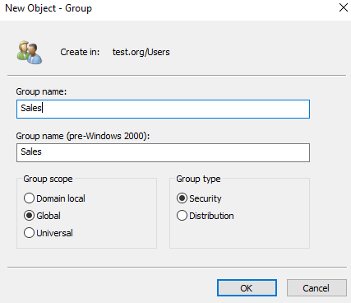

*2.2.1 Group naming*

### 2.3 Organizational unit

To create an organisational unit simply right-click on the domain object, navigate to new and select organizational unit. You will be prompted to choose a name along with the option of protecting the container from accidental deletion. Once you are done click ok and the OU is created. In my domain I have created 3 OU which I will transfer the users and groups in the user object. Below are the steps to do so

* Navigate to a user or group in the Users container
* Right click on the user or group and select move
* Select the appropriate container to move and press ok
* Proceed to do this for the other users and group

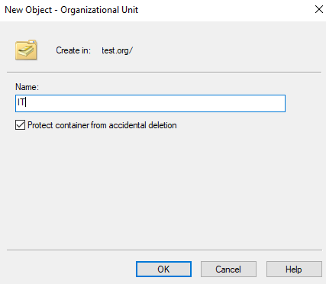

*2.3.1 OU creation*

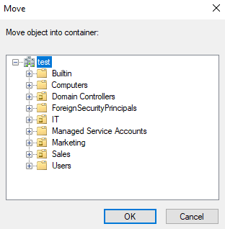

*2.3.2 Moving user and group*

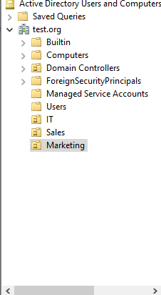

*2.3.3 Added Ous*

### 2.4 Adding users to groups

There are many ways to add a user to a group and the steps below are one of them

* Right click on the group and select properties
* Under the members tab click add
* Type the user in the text box and click check names to pull up the user
* Select Ok then apply to successfully add the user

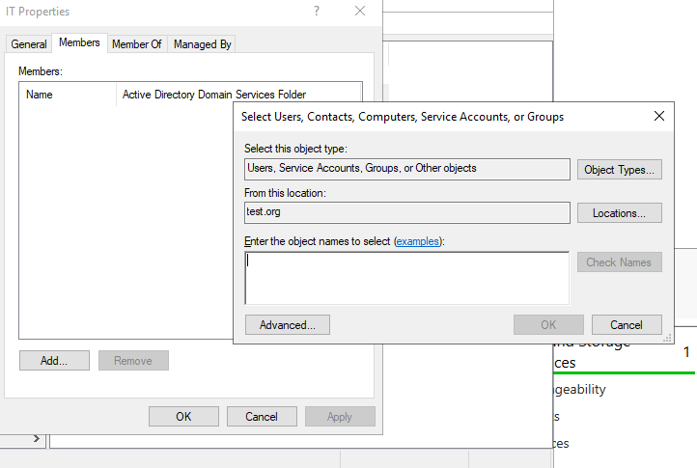

*2.4.1 Adding user to group*

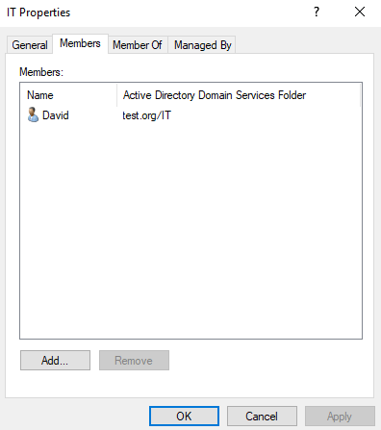

*2.4.2 Confirmation of user addition*

## 3.0 Group Policy

In section 2 we created organizational units moving users from the previous container. The reason this is done is to apply certain group policies that will take into effect for every computer system or user present in the organisational unit for centralized management. In this section we will create and link GPOs to OUs and attempt some setting changes

### 3.1 Creating and Linking GPOs

Below are the steps to do so

* Navigate to the top right of the server manager dashboard and select tools
* Under tools select group policy management
* Navigate until to find the OU you want to create and link GPO(forest>domains>target domain>OU)
* Right click OU and select “Create a GPO in this domain, and link it here”

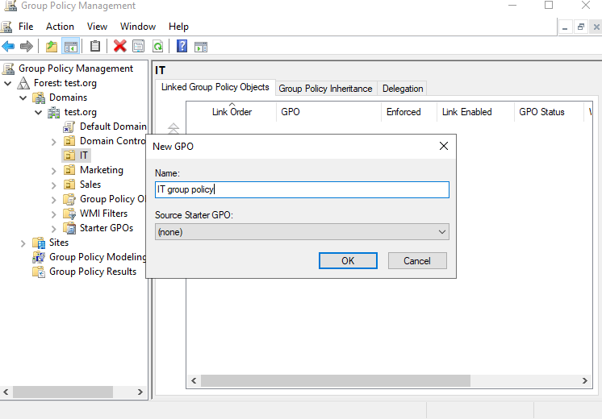

*3.1.1 Naming group policy*

### 3.2 System setting changes via GPO

Using the GPO, global settings can be applied to every user and computer in the GPO. For this example, we will apply a new power plan to the user “David linked to the GPO we created in 3.1. Below are the steps

* Right click on group policy and click edit
* Under user configuration navigate to preferences>control panel settings>power options
* Right click on power options, select new then power plan
* In the power plan window properties select the drop-down option under action and click create
* Name the power plan, make any changes to the settings, click apply then ok

N/B: Group policy periodically update every 90 minutes so in order to force it right click run to open the run dialog box and type “gpupdate

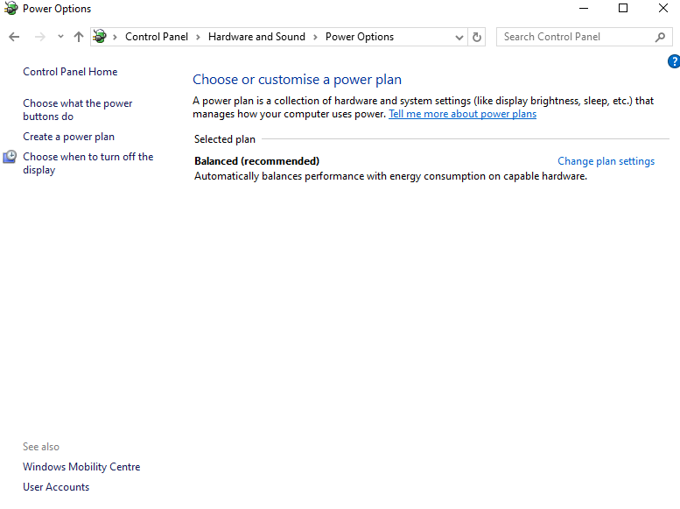

*3.2.1 Previous power plan option before GPO update*

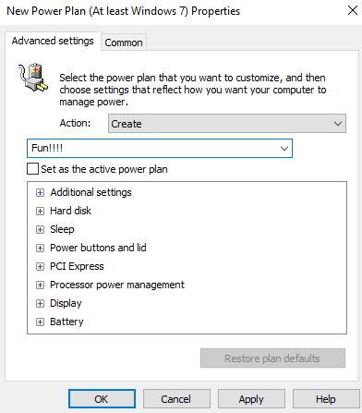

*3.2.2 Creating Power Plan*

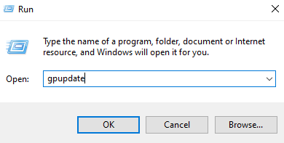

*3.2.3 Run command*

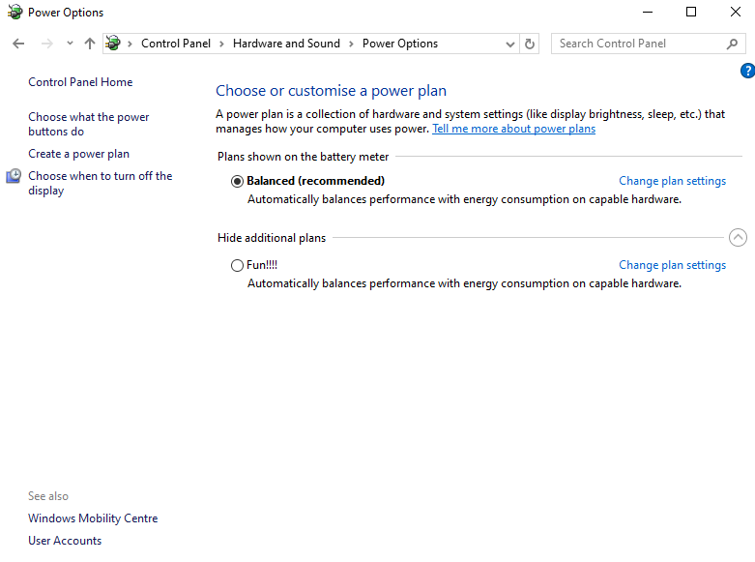

*3.2.4 New power option*

## 4.0 File permissions

In this section we will briefly demonstrate how file permission can be set through the domain controller. We will be giving a user access to one user while excluding another.

### 4.1 Mapping network drive

First we will need to map a folder to a network drive in order for the user to access it. Below are the steps

#### 4.1.1 Setting user or group permissions on folder

* Navigate to desktop and create a folder
* Right click on the folder and select properties
* Navigate to the security tab, select edit and in the new window select add
* Enter the user or group name into the text box and select check name to pull it up
* Select name then click ok
* Select newly added user, adjust permissions appropriately, select apply on the security window, then ok

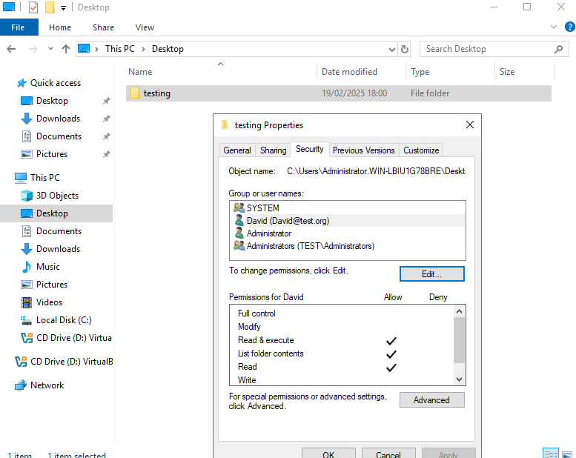

*4.1.1.1 User with file permission*

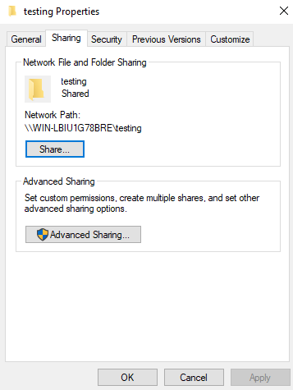

*4.1.1.2 Network path*

#### 4.1.2 Mapping drive in GPO

* On the top right corner of the server manager dashboard click tools and select group policy management
* Right-click previously created GPO and select edit
* Navigate to drive maps (User configuration>preferences>windows settings>drive maps)
* Right click on drive maps, select new then mapped drives
* In the new drive properties window, select create in the action drop-down menu and specify the network path in the location text box
* Tick the reconnect button, select a drive letter, select show this and all drives, select apply then ok

N/B: Restart both machines for the networks to appear on control panels

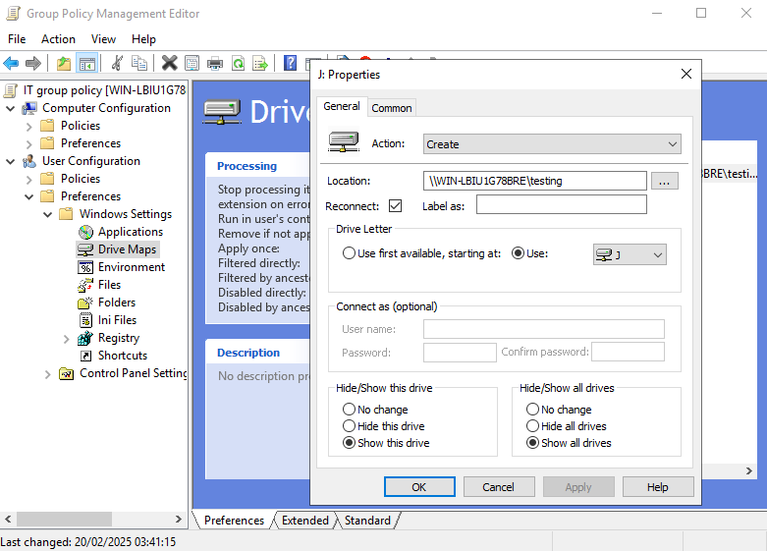

*4.1.2.1 Drive map creation*

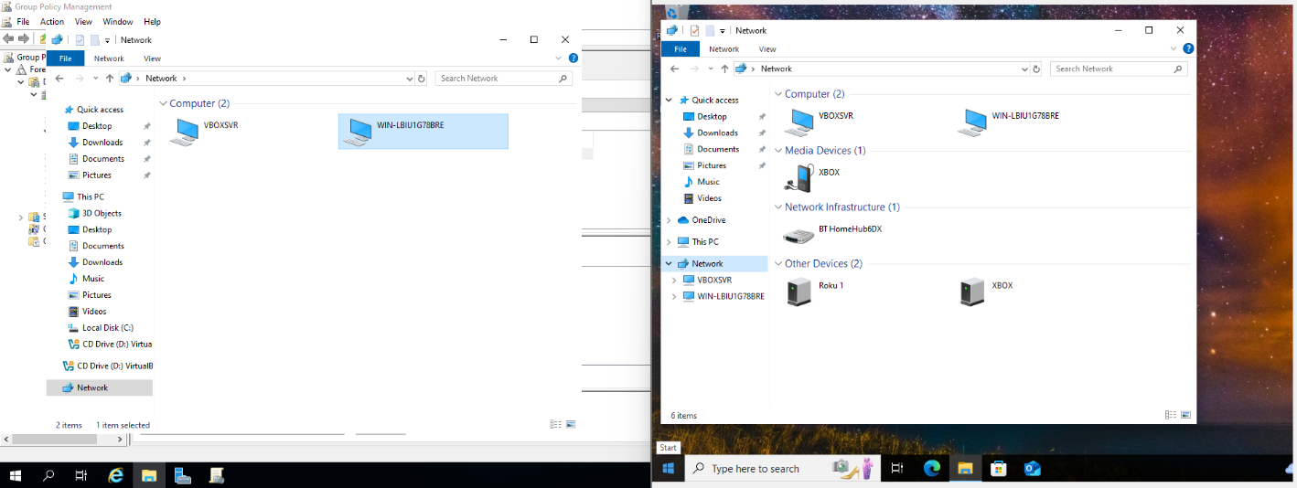

*4.1.2.2 Network confirmation on both PC*

### 4.2 Testing permission

In my instance of setting file permission the user was not given write permissions meaning they cannot change contents of the file but they can read it. Below are the steps to verify the permission were enforced.

* On the user account, open file explorer and select network
* Under the computers in network, select the domain controller
* Select the shared folder and open the file
* Attempt to edit it and save

An error will pop up saying you do not have permission.

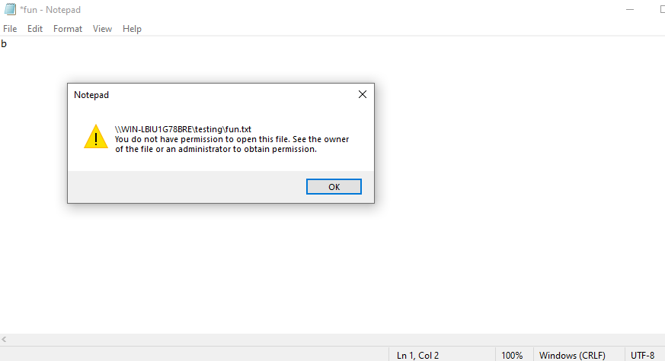

*4.2.1 Permission verified*

## 5.0 Further practice

Below are practices to attempt in your free time

* Unlocking accounts
* Password resets
* Creating, modifying and disabling accounts
* Remote support